TDX
Supervisor Approval Process

OVERVIEW
This training document explains how to approve, approve with conditions, and reject a UKANS and KURES P-Card application for a new P-Card or a P-Card permanent change.

INFORMATION REQUIRED TO COMPLETE THIS TASK
- Completed New P-Card Application or Permanent Change Form.
- Access to Email

INSTRUCTIONS
STEP ONE:

Before starting the process, a user must complete a New P-Card Application or Permanent Change Form. The online form is available from https://hawkhelp.ku.edu/TDClient/631/Portal/Requests/ServiceDet?ID=7702

STEP TWO:
When you have a request to approve, you should receive an email with the subject “TeamDynamix Workflow Step Assignment (Supervisor Approval)”
Open the email. It should appear like this:
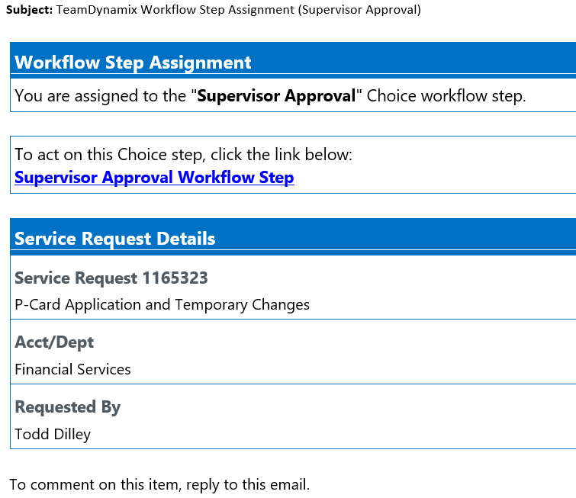

STEP THREE:
Click on the Supervisor Approval Workflow Step in the email.

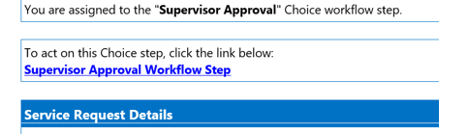

You should be directed to a TDX approval screen. (Please note, that you may be required to log in via a SSO screen)

STEP FOUR:

Select the Service Request link, which will display the important information about the request.

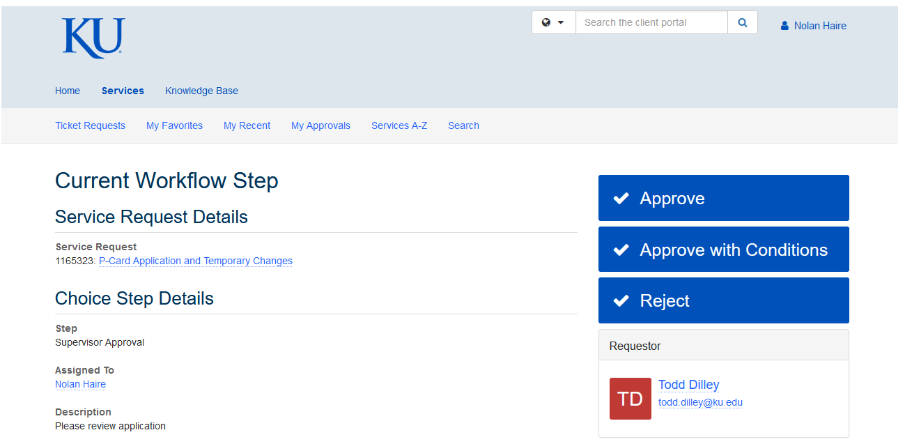

STEP FIVE:

This screen displays all important information regarding the transaction. Please review before continuing.

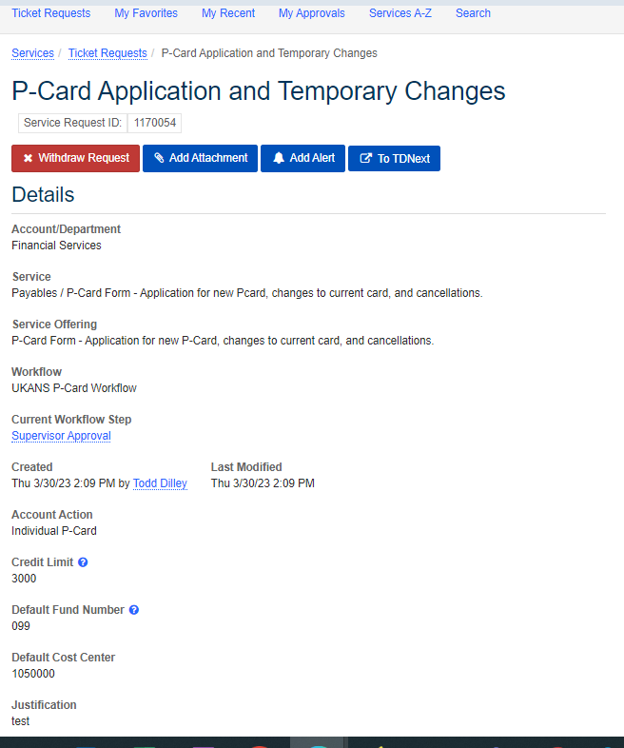
Details of the ticket will display depending on the specific request that a user has made.

A few fields to note:

Workflow - Indicates this is a UKANS or KURES request.

Created – When and who created the request.

Account Action – Can vary between
Individual P-Card, Temp changes, Permanent Changes, etc. This example, was created for an Individual P-Card.

Credit Limit- Displays requested credit limit.

Default Fund Number/Cost Center - Displays requested Default Fund and Cost Center. Cannot use fund 9X8 for KURES P-Cards.

Justification – Displays a user’s justification for their request.

After reviewing the transaction’s information, select the browser’s back button to return to the Approver’s Page to proceed.

STEP SIX:

On the right side of Approver’s page there will be an area where you can Approve, Approve with Conditions, and Reject the request. Please note, these options can change depending on the process and what needs approved.
Approve – Approves request as-is. The request will be forwarded to the UKANS or KURES approval group to process.

Approve with Conditions – Approves request and opens a dialog box where changes can be made. i.e. (changed cost center, fund number, credit limit, etc). Request will be forwarded to the UKANS or KURES approval group to process.

Reject – Reject’s the users request and sends a notification email.

A few fields to note:

Workflow - Indicates this is a UKANS request and it’s workflow

Created – When and who the request was created by

Account Action – Can vary between
Individual P-Card, Temp changes, Permanent Changes, etc. This example, was created for an Individual P-Card

Credit Limit- Displays requested credit limit.

Default Fund Number/Cost Center - Displays requested Default Fund and Cost Center

Justification – Displays a user’s justification for their request.

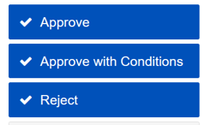

STEP SEVEN:

You will receive a confirmation on your screen.

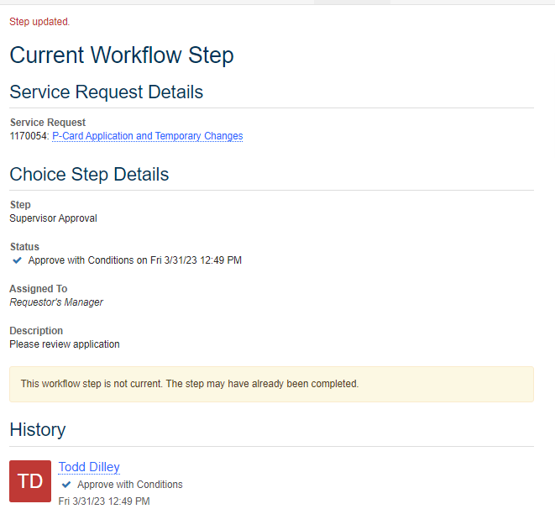

End of Procedure

